**GIT-5**

Execute steps involving clean up and push back to remote Git.

Step1: Verifying If Master Is in Clean State

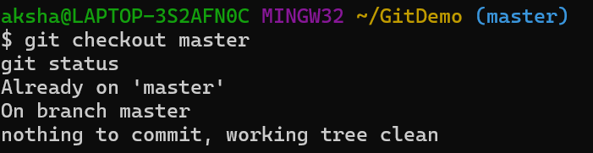

Step2: Listing All Local Branches

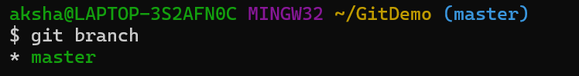

Step3: Pulling the Latest Remote Changes to Master

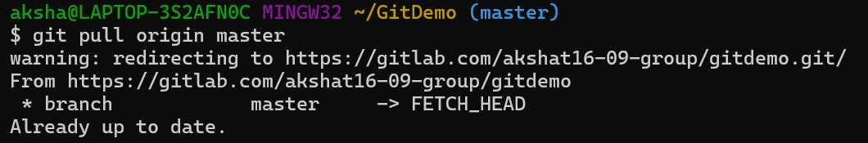

Step4: Pushing Pending Changes to Remote

